**Creating Load Balancer with Web Application in AWS Using Route 53**

In this guide, we will be going to create an architecture for a web application that is connected to AWS Route 53 with an actual live domain name that we can test in this environment. So will be creating two EC2 instances with separate subnets in two different availability zones. An Elastic Load Balancer (ELB) will be required and then we will use AWS Route 53 to point our domain to AWS ELB and server traffic from the two EC2 instances.

We will be following the below architecture.

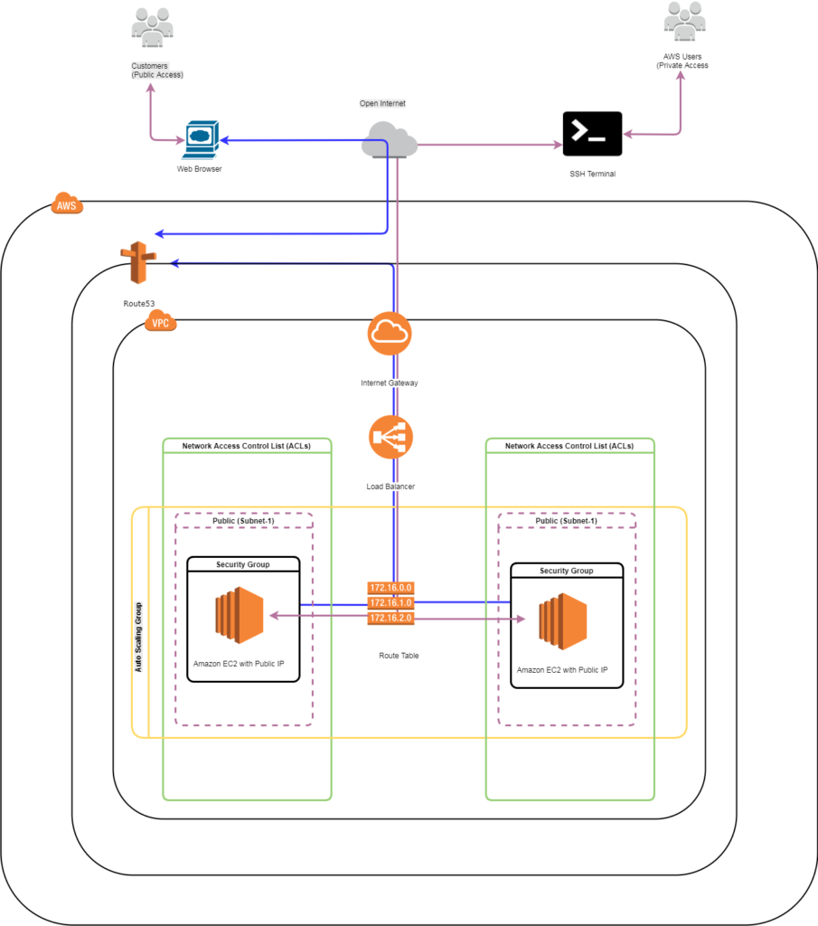

This guide assumes that you already have Virtual Private Cloud. So, first of all, we will be creating two Amazon EC2 instances, click here if you want to know in detail about [how to create an Instance on AWS.](http://linuxnoobcast.com/2017/10/21/provisioning-an-ec2-instance/)

**Note: In this guide please ignore if you find any VPC name difference or subnet name difference. The procedure is same as mentioned in this guide.**

In **Step 3** we will be configuring as below and click on **Next**

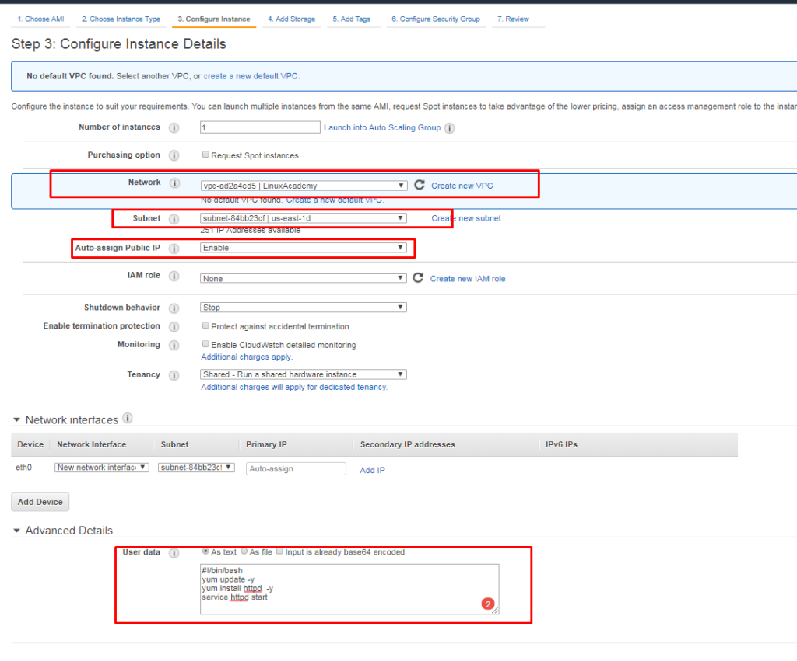

In **Step 4** it will ask for Add storage leave it as defaults and click on Next

In **Step 5** it will ask for Tags configure it as mentioned below

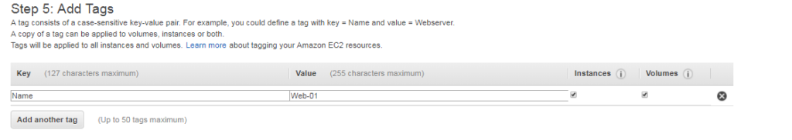

In **Step 6** we will be adding new security group and HTTP rule as well to that security group.

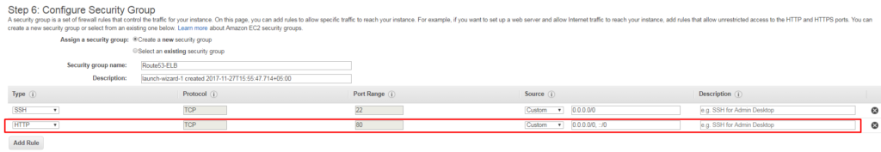

In **Step 7** Launch the instance, it will ask for the keypair download it. After that launch the instance

In **Step 7** Launch the instance, it will ask for the keypair download it. After that launch the instance

Repeat the same steps of the second EC2 instance as well. But below step will be different.

**Step 3** : Choose a different subnet

**Step 6** : Choose the security group that you have created earlier

**Step 7** : Use the existing keypair by clicking on I Acknowledge

After the successfully provisioned EC2 instance we will be checking with Public default page of Apache HTTP server

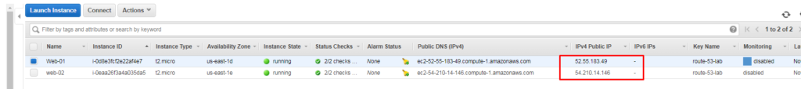

**For web-01**

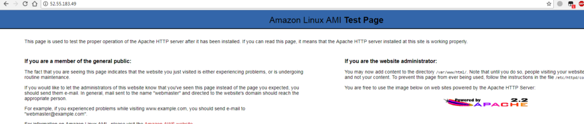

**For web-02**

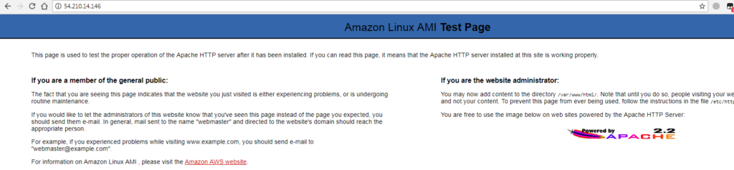

Now that we have created the instances we will be creating Load Balancer. Goto EC2 console and click on Load Balancers after that click on Create Load Balancers

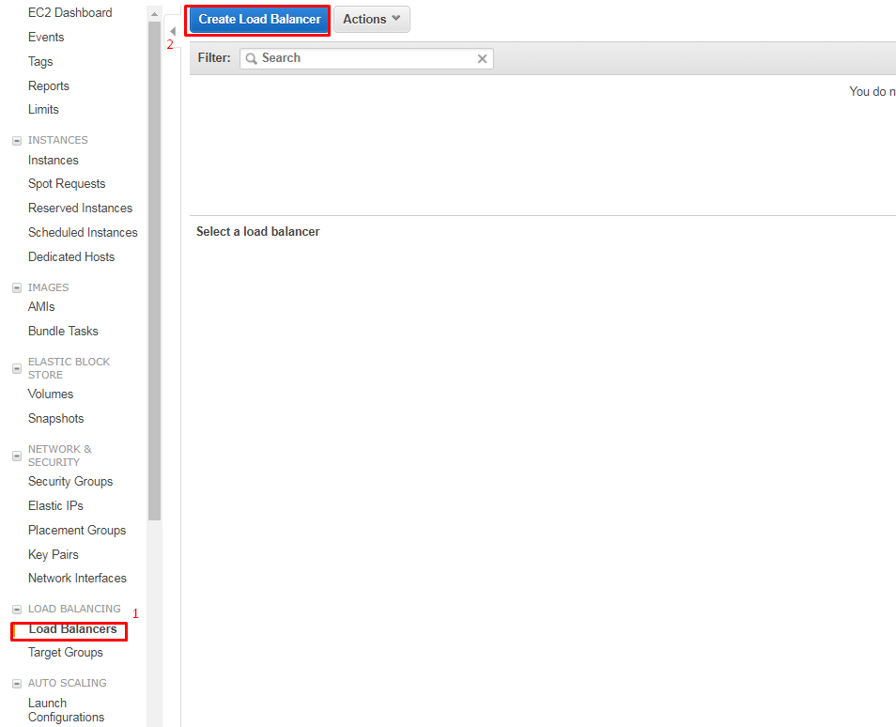

Select the type of Load Balancer

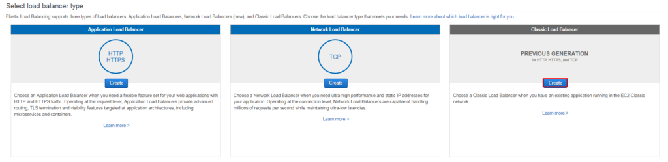

**Step 1:** We will be selecting a name of the ELB and adding the subnet to it. Click **Next**

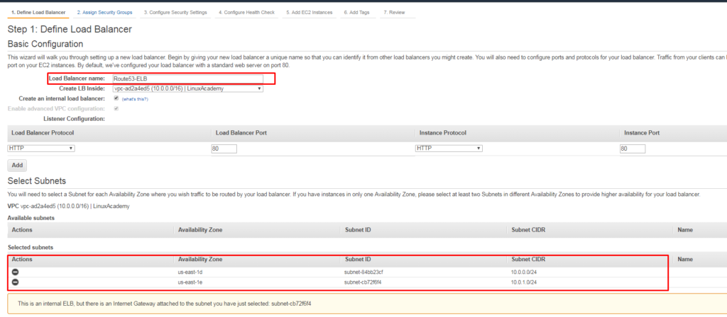

**Step 2:** Assign Security group, here we will be creating a new security group. After that click on **Next**

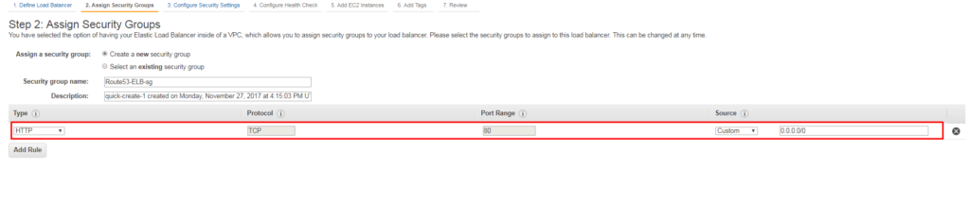

**Step 3** : It will ask for the security settings ignore

**Step 4** : It will ask for Health Checks

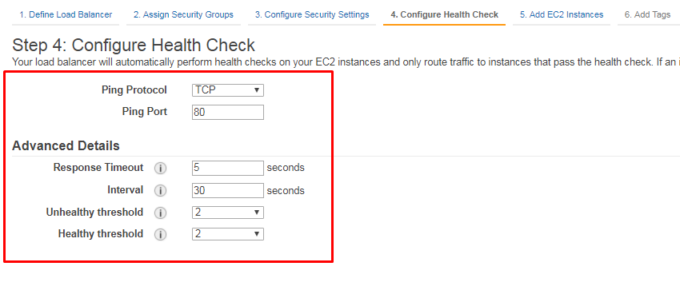

**Step 5** : Add EC2 instances

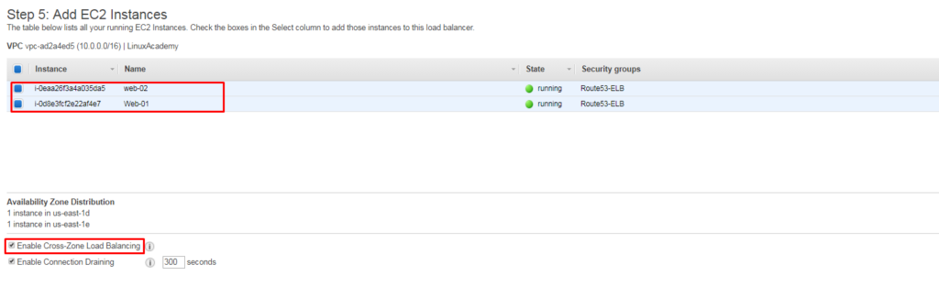

**Step 6** : It will ask for Tags, depends on your need but here we will leave it as blank

**Step 7** : Review and click on Create

After completing the Step 7 it will go to Load Balancer screen here you will find the instances tab which will be showing it is out of service after about 3 to 4 minutes it will in InService state.

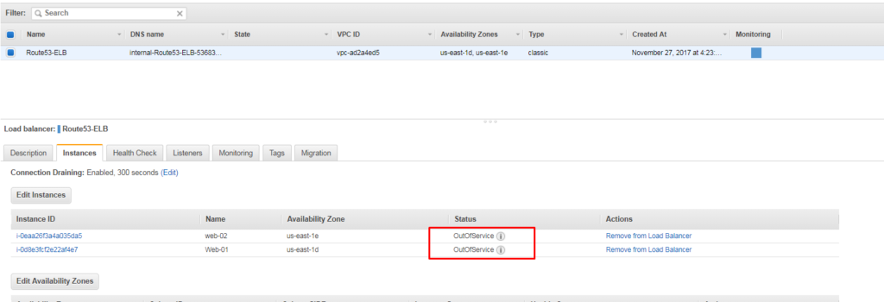

Now we will go to Description Tab and find out the DNS name and then paste into the browser to confirm that traffic is going from ELB. It will show the Apache default page that means you have successfully configured the ELB.

Now for pointing the domain name towards the ELB we will be going to Route53 console. In Route53 you have to create a hosted zone and buy a domain name, after that when you Route53 the main dashboard you will see hosted zone as 1. Click on that and create a two new Records one with blank name and the other one will be with “www”. For both records, we will be selecting alias “YES” and select ELB name in the field and click on save a record.

Now when we goto the browser and type our hosted zone domain name we will be getting Apache Default page, which shows Route53 is successfully configured and is forwarding traffic to ELB.